## Gradient from the top left corner to the bottom right corner, blue to green color

## Author's contact detailsTyrannosaurus Rex

Table of Contents

0

0

Viking beads proposal 2

Description 2

Scope 2

ER design 2

Requirement analysis 2

ER Diagram 3

Relational Schema 4

Transluceny 4

color 4

Bead 4

Pattern 4

proportion 4

eye 4

shape 5

Size 5

Material 5

Method 5

Site 5

Museum 5

FOUND 6

Context 6

Identifier 6

Period 6

SQL implementation 6

Table Creation 6

Insert Statements 11

User interface design 20

Website Demo – offline mode 21

Display [Backup] 21

Insert [Backup] 23

Remove[Backup] 24

# Viking beads proposal

## Description

For our project we are creating a database to help identify historic Nordic beads. Due to the number of variables that must be accounted for correct categorization (color, shape, material etc.), this process can be difficult without extensive prior knowledge in the subject. Simply put, our goal was to create a web-based database that will allow users to quickly identify beads by characteristic, designation, or locality.

With this database, we believe we have accomplished this goal. It features a comprehensive list of characteristics, as well as supporting information such as the time period it originated from or the museum that it is housed. All of this is to better assist users in their queries.

## Scope

This database design focused on bead styles and characteristics of beads found among Norse artifacts. Because of this, many of the characteristics and factors accounted for in the database focus on ones available to Norse craftspeople at the time. While the initial database is limited, the database was designed in a way to allow expansion to other cultures and other beads with only minor tweaking. We wish we could have made room for any bead out there, but keeping the database in scope meant making decisions tailored towards a better final product.

# ER design

## Requirement analysis

To accurately identify the bead, there are a multitude of variables that need to be considered. First is the method that was used to produce the bead. This is a combination of the materials that were used (whether that be glass, stone, or other) as well as the technique that was used to produce the bead. The next aspect consider is the physical structure of the bead. Since this might be the only information that someone might have on a bead, it can prove vital to accurately identifying it. For this we look at several key factors. The first being the proportions of the bead, in addition the shape, and the size of the loophole. Lastly, we also need to look at the color of the bead which can be divided into two subcategories, color and opacity. These are vital in differentiating similar beads and properly dating them.

Next, we added in relations for where the beads are held. Since this can change, we designed the ER diagram to pair a unique bead identifier with the museum identifier to allow for ease of switching bead locations. The last factor is the site location, the site describes where the beads originated from. This can include the period in which the bead circulated as well as the location where the bead was originally from.

## ER Diagram

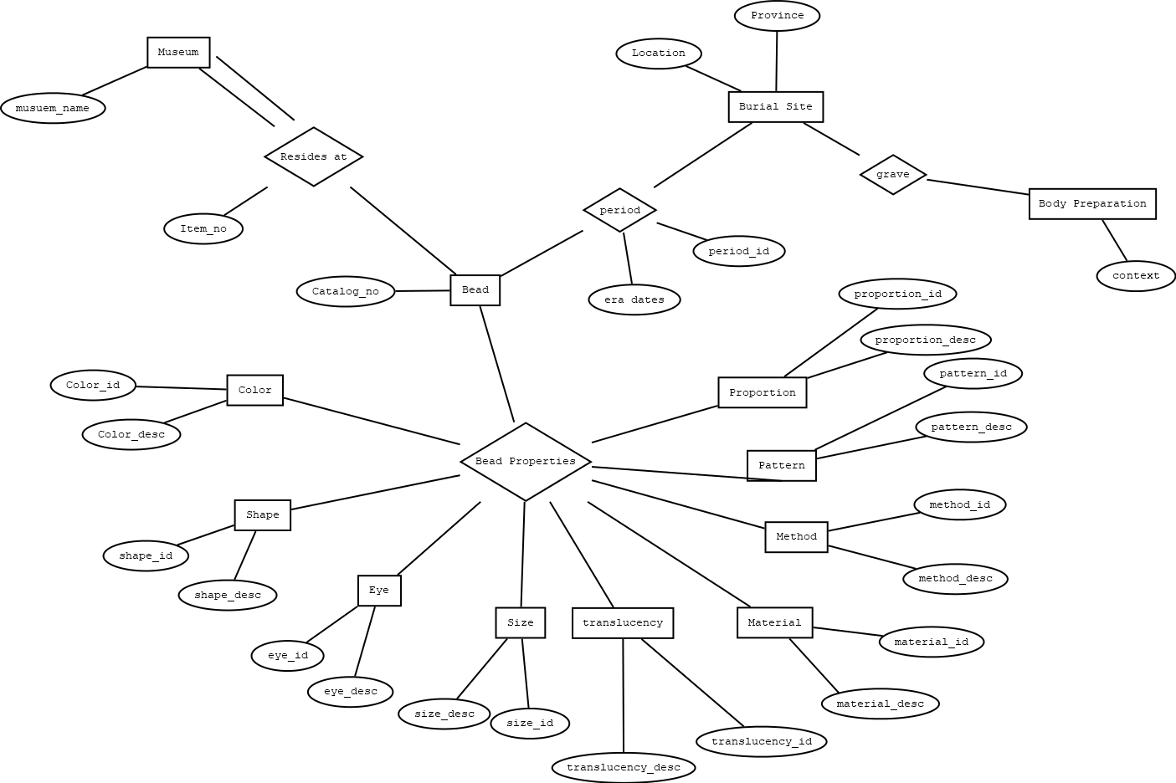

# Relational Schema

## Transluceny

**Translucency(Translucency: INTEGER, Translucent_Desc: VARCHAR(35))**

The translucent table describes the translucency of the bead. It consists of Translucent_ID as the primary key and Translucent Description, which illustrates the approximate translucency of the bead.

## color

**Color (Color_ID: INTEGER, Color_Desc: VARCHAR(35))**

The Color table describes the color of the bead each color given a specific ID. It consists of Color_ID which is the primary in the table and Color Description.

## Bead

**Bead(Catalog_NO: INTEGER, color_id: INTEGER method_id: INTEGER, shape_id: INTEGER, size_id: INTEGER pattern_id: INTEGER, proportion_id: INTEGER, period_id: INTEGER, translucency_id: INTEGER, material_id: INTEGER)**

The Bead table assigns a Bead a Unique Catalog_NO as well as a unique Item_Number both of which can be interchangeable as primary keys but in this table Catalog_NO is the primary key.

## Pattern

**Pattern(pattern_id: INTEGER, pattern_desc: VARCHAR(35))**

The pattern table represents the markings and identifiable patterns on the beads. Pattern_id represents the primary key while the pattern_desc describes the distinct pattern for each id.

## proportion

**Proportion(Proportion_ID: INTEGER, Proportion_Desc: VARCHAR(35))**

The Proportion table assigns a bead a unique Proportion_ID as well as a Proportion_Desc in order to identify the unique patterns for each bead. The primary key in this table is Proportion_ID.

## eye

**Eye(eye_id: INTEGER, eye_desc: VARCHAR(35))**

Eye_id represents the primary key of the eye table. A number is assigned to represent the diameter of the string hole, if applicable. Eye_desc gives an approximate measurement.

## shape

**Shape(shape_id: INTEGER, shape_desc: VARCHAR (35))**

Shape is one of the most distinct things about beads, yet certain patterns emerge. In light of that, this database takes into account the various patterns found, while using a unique numerical identifier to represent combinations found.

## Size

**Size(size_id: INTEGER, size_desc: VARCHAR(35))**

The size table simply describes the size of the bead, categorizing them by their physical dimensions and assigning a unique identifier to each category that also serves as primary key.

## Material

**Material (Material_id: INTEGER, Material_desc: VARCHAR(35))**

The material table takes into account the composition of the bead, be it glass, crystal, rocks, or some combination thereof. Then, it assigns a unique identifier as a primary key to each combination.

## Method

**Method(Method_Code: VARCHAR(5), Material: VARCHAR(30), Technique: VARCHAR(50))**

The Method table describes the methods of bead creation. It consists of Method_Code which acts as the primary key, as well as a description of the technique.

## Site

**Site (Site: VARCHAR(35), Feature: VARCHAR(35), Province: VARCHAR(35), Context: CHAR(35), Catalog_NO: INTEGER)**

The Site table is describing where the bead was found and catalogs it. The Site and Feature act as primary keys for the table. Other attributes include Province, Context and Catalog_NO which acts as a foreign key from the bead table.

## Museum

**Museum(Item_NO: INTEGER, Museum_name: CHAR(20))**

The Museum table represents where the beads are housed. Item_NO is the primary key in the table, which is derived from the museum's unique identifier for the bead. It also includes the name of the museum where the bead is found.

FOUND

**Found(site varchar (35), catalog_no varchar (35))**

Site references the primary key of the Site table and catalog_no references the primary key of the Bead table. Together they form the primary key for the found table. This table allows the database to track which bead came from what site.

## Context

**Context_id(Item_no: INTEGER, context_desc: VARCHAR(35))**

Context references how body was interred, which can affect the condition of the bead. Context_id serves as a unique identifier, while context_desc provides details on the funeral rites and interring method used.

## Identifier

**Identifier (catalog_no: VARCHAR (35), item_no: VARCHAR (35))**

Catalog_no references the primary key of the Bead table. Item_no references the primary of the museum table. Together they form the primary key of the Identifier table, linking those parts of the database together.

## Period

**Period(Period_NO: INT, Dates: VARCHAR(35))**

The Period table represent the era of when the bead was believed to be buried. Period_NO acts as the primary key, which is both a recognized historical period among bead enthusiasts. Dates represents a more common historical identifier.

# SQL implementation

## Table Creation

###TABLE CREATOR##

use jal23db

##Cleanup the old stuff##

DROP TABLE IF EXISTS identifier;

DROP TABLE IF EXISTS found;

DROP TABLE IF EXISTS bead;

DROP TABLE IF EXISTS site;

DROP TABLE IF EXISTS pattern;

DROP TABLE IF EXISTS proportion;

DROP TABLE IF EXISTS translucency;

DROP TABLE IF EXISTS shape;

DROP TABLE IF EXISTS material;

DROP TABLE IF EXISTS method;

DROP TABLE IF EXISTS size;

DROP TABLE IF EXISTS color;

DROP TABLE IF EXISTS eye;

DROP TABLE IF EXISTS period;

DROP TABLE IF EXISTS museum;

DROP TABLE IF EXISTS context;

##Basic association tables

CREATE TABLE period (

period_id INT,

dates varchar (35),

PRIMARY KEY (period_id)

)ENGINE=InnoDB;

create table proportion (

proportion_id int,

proportion_desc varchar (35),

primary key (proportion_id)

)ENGINE=InnoDB;

create table translucency (

translucency_id int,

translucency_desc varchar (35),

primary key (translucency_id)

)ENGINE=InnoDB;

create table shape (

shape_id int,

shape_desc varchar (35),

primary key (shape_id)

)ENGINE=InnoDB;

create table material (

material_id int,

material_desc varchar (35),

primary key (material_id)

)ENGINE=InnoDB;

create table method (

method_id int,

technique varchar (35),

primary key (method_id)

)ENGINE=InnoDB;

create table size (

size_id int,

size_desc varchar (35),

primary key (size_id)

)ENGINE=InnoDB;

create table color (

color_id int,

color_desc varchar (35),

primary key (color_id)

)ENGINE=InnoDB;

create table pattern (

pattern_id int,

pattern_desc varchar (35),

primary key (pattern_id)

)ENGINE=InnoDB;

create table eye (

eye_id int,

eye_desc varchar (35),

primary key (eye_id)

)ENGINE=InnoDB;

##How it was found, how it was stored

create table museum (

item_no varchar (35),

museum_name varchar (35),

primary key (item_no)

)ENGINE=InnoDB;

create table context (

context_id int,

context_desc varchar (35),

primary key (context_id)

)ENGINE=InnoDB;

create table site (

site varchar (35),

province varchar (35),

context_id int,

primary key (site),

foreign key (context_id) references context (context_id)

)ENGINE=InnoDB;

##Primary bead table

create table bead (

catalog_no varchar (35),

color_id int,

method_id int,

shape_id int,

size_id int,

pattern_id int,

proportion_id int,

period_id int,

translucency_id int,

material_id int,

primary key (catalog_no),

foreign key(color_id) references color(color_id),

foreign key(method_id) references method(method_id),

foreign key(shape_id) references shape (shape_id),

foreign key(size_id) references size(size_id),

foreign key(pattern_id) references pattern(pattern_id),

foreign key(proportion_id) references proportion(proportion_id),

foreign key(period_id) references period(period_id),

foreign key(translucency_id) references translucency (translucency_id),

foreign key(material_id) references material(material_id)

)ENGINE=InnoDB;

#Tables with greatest dependencies

create table found(

site varchar (35),

catalog_no varchar (35),

primary key(site, catalog_no),

foreign key(site) references site(site),

foreign key(catalog_no) references bead(catalog_no)

)ENGINE=InnoDB;

create table identifier (

catalog_no varchar (35),

item_no varchar (35),

primary key (catalog_no, item_no),

foreign key (item_no) references museum (item_no),

foreign key (catalog_no) references bead (catalog_no)

)ENGINE=InnoDB;

## Insert Statements

##########################################################################

##########################################################################

#

#insert statements

#

##########################################################################

##########################################################################

insert into period (period_id,dates) values (1,'790-820');

insert into period (period_id,dates) values (2,'820-845');

insert into period (period_id,dates) values (3,'845-860');

insert into period (period_id,dates) values (4,'860-885');

insert into period (period_id,dates) values (7,'885-915');

insert into period (period_id,dates) values (8,'915-950');

insert into period (period_id,dates) values (6,'950-960');

insert into period (period_id,dates) values (9,'960-980');

insert into period (period_id,dates) values (12,'980-1000');

insert into period (period_id,dates) values (0,'Unspecified');

insert into proportion values (151,'Short');

insert into proportion values (152,'Medium short');

insert into proportion values (153,'Medium-long');

insert into proportion values (154,'Long');

insert into proportion values (1512,'Short to medium short');

insert into proportion values (1513,'Short to medium long');

insert into proportion values (1514,'Medium short to medium long');

insert into proportion values (1515,'Medium short to long');

insert into proportion values (1516,'Medium long to long');

insert into translucency values (181,'Translucent glass');

insert into translucency values (182,'Semi-translucent glass');

insert into translucency values (183,'Opaque glass');

insert into translucency values (184,'Opaque glass, no light passes');

insert into shape values (121,'Spheric');

insert into shape values (122,'Rounded without plane parallel ends');

insert into shape values (123,'Rounded and ribbed without plane parallel ends');

insert into shape values (124,'Rounded with plane parallel ends');

insert into shape values (125,'Rounded and ribbed with plane parallel ends');

insert into shape values (126,'Rounded with tordated ends');

insert into shape values (127,'Cylindrical');

insert into shape values (129,'Flat');

insert into shape values (130,'Cylindroid with oval section');

insert into shape values (131,'Truncated cone');

insert into shape values (132,'Truncated bicone, the bases of the cones are identical with the equator');

insert into shape values (133,'Truncated bicone, the bases are the ends of the bead');

insert into shape values (134,'Rectangular prismatic');

insert into shape values (135,'Rectangular prismatic with cut corners');

insert into shape values (136,'Pentagonal rectangular prismatic');

insert into shape values (137,'Hexagonal rectangular prismatic');

insert into shape values (138,'Assymetrical hexagonal bipyramidal');

insert into shape values (139,'Octagonal rectangular prismatic');

insert into shape values (140,'Assymetrical octagonal bipyramidal');

insert into shape values (141,'Hexagonal oval');

insert into shape values (142,'Octagonal rectangular prismatic with faceted sloping ends');

insert into shape values (143,'Symmetrical hexagonal bipyramidal');

insert into shape values (144,'Symmetrical octagonal bipyramidal');

insert into shape values (145,'Planum parallel rhomboid discoid with faceted edges');

insert into shape values (146,'Octagonal truncated cone');

insert into shape values (147,'Globular, hexagonal-octagonal with quadrangular to hexagonal facets');

insert into shape values (148,'Planum parallel rounded discoid with facetted edges');

insert into material values ('999','Blown Glass');

insert into material values ('998','Rock Crystal');

insert into material values ('997','Jade');

insert into material values ('996','Fayance');

insert into material values ('995','Amethyst');

insert into material values ('994','Undetermined');

insert into material values ('993','Derivative glass');

insert into material values ('992','Composite glass');

insert into material values ('991','Wound Glass');

insert into material values ('990','cornelian and agate');

insert into material values ('989','amethyst');

insert into material values ('988','jade');

insert into material values ('987','Undetermined/unidentified');

insert into material values ('986','Undetermined/no classification');

insert into method values ('1001','Warm-made, undecorated wound');

insert into method values ('1002','Warm-made decorated, wounds');

insert into method values ('1003','Warm-made decorated folded(not divided into individual types)');

insert into method values ('1004','Warm-made blown and drawn segmented with a wall thickness of less than 0.05 cm and with silver folium');

insert into method values ('1005','Warm-made blown and drawn segmented with a wall thickness of more than 0.05 cm');

insert into method values ('1006','Warm-made blown and drawn simply cut');

insert into method values ('1007','Warm-made decorated');

insert into method values ('1008','Derivatives without yellow-red-white-blue ends. May also occur with yellow, red inscribed center with light and dark green rays.');

insert into method values ('1009','Derivative May also occur with yellow, red inscribed center with light and dark green rays.');

insert into method values ('1010','Composite');

insert into method values ('1011','Cold-made');

insert into method values ('1012','Worked');

insert into size values (161,'Small micro-beads');

insert into size values (162,'Medium micro-beads');

insert into size values (163,'Large micro-beads');

insert into size values (164,'Small middle-sized beads');

insert into size values (165,'Medium middle-sized beads');

insert into size values (166,'Large middle-sized beads');

insert into size values (167,'Small macro-beads');

insert into size values (168,'Medium macro-beads');

insert into size values (169,'Large macro-beads');

insert into size values (170,'Very large macro-beads');

insert into size values (171,'Giant beads');

insert into color values (201,'Noncolored');

insert into color values (202,'White');

insert into color values (203,'Greyish white');

insert into color values (204,'Grey');

insert into color values (205,'Black');

insert into color values (206,'Yellow');

insert into color values (207,'Greyish yellow');

insert into color values (208,'Orange');

insert into color values (209,'Red');

insert into color values (210,'Yellow brown');

insert into color values (211,'Brownish red');

insert into color values (212,'Dark brown');

insert into color values (213,'Malva');

insert into color values (214,'Dark blue');

insert into color values (215,'Forget-me-not blue');

insert into color values (216,'Bluish grey');

insert into color values (217,'Bluish green');

insert into color values (218,'Pale turquoise');

insert into color values (219,'Light green');

insert into color values (220,'Medium green');

insert into color values (221,'Dark green');

insert into color values (222,'Greyish green');

insert into color values (223,'Silver');

insert into color values (224,'Gold');

#insert into pattern ('pattern_id', 'pattern_desc') values (,'');

insert into pattern values (501,'Central Straight Ring');

insert into pattern values (502,'Central Straight Ring framed by Eyes');

insert into pattern values (503,'Nonsymmetric Straight Rings');

insert into pattern values (504,'Nonsymmetric Straight Rings dotted with Eyes');

insert into pattern values (506,'Single Straight Rings');

insert into pattern values (509,'Single Row of Eyes framed by Single Straight Rings');

insert into pattern values (522,'Zigzag Ring framed by Eyes');

insert into pattern values (525,'Parallel Zigzag Rings');

insert into pattern values (541,'Wavy Ring');

insert into pattern values (543,'Parallel Wavy Rings');

insert into pattern values (546,'Mirrored Wavy Rings');

insert into pattern values (549,'Single Row of Eyes framed by Mirrored Wavy Rings');

insert into pattern values (551,'Diagonal Lattice Patterns framed by Mirrored Wavy Rings');

insert into pattern values (553,'Two Wavy Rings Interwoven');

insert into pattern values (555,'Two Wavy Rings Interwoven overlaid with Intersecting Ovals');

insert into pattern values (556,'Rectilinear Lattice Patterns framed by Mirrored Wavy Rings');

insert into pattern values (557,'Eyes framed by Two Wavy Rings Interwoven');

insert into pattern values (558,'Eyes framed by Four Wavy Rings Interwoven');

insert into pattern values (559,'Three Rows of Eyes framed by Wavy Rings Interwoven');

insert into pattern values (561,'Bowed Wavy Ring');

insert into pattern values (586,'Mirrored Wide Wavy Rings');

insert into pattern values (590,'Eyes framed by Mirrored Wide Wavy Rings framed with Eyes');

insert into pattern values (601,'Curled Wavy Ring');

insert into pattern values (606,'Mirrored Curled Wavy Rings');

insert into pattern values (621,'Irregular Wavy Ring');

insert into pattern values (623,'Parallel Irregular Rings');

insert into pattern values (701,'Straight Ring overlaid with a Wavy Ring');

insert into pattern values (702,'Straight Ring overlaid with a Wavy Ring framed by Two Straight Rings');

insert into pattern values (714,'Straight Ring overlaid with Two Wavy Rings Interwoven');

insert into pattern values (762,'Wavy Ring framed by Two Straight Rings');

insert into pattern values (763,'Wavy Rings framed by Two Straight Rings');

insert into pattern values (782,'Zigzag Rings or Herringbone Pattern framed by Two Straight Rings');

insert into pattern values (783,'Irregular Zigzag Rings framed by Two Straight Rings');

insert into pattern values (786,'Single Wavy Rings alternating with Single Straight Rings');

insert into pattern values (787,'Single Wavy Rings alternating with Double Straight Rings');

insert into pattern values (788,'Wavy Ring framed by Two Straight Rings framed by Two Bowed Wavy Rings');

insert into pattern values (790,'Wavy Ring framed by Two Straight Rings framed by Two Rows of Eyes');

insert into pattern values (794,'Wavy Ring overlaid by Two Wavy Rings Interwoven framed by Two Straight Rings');

insert into pattern values (811,'Straight Stripes framed by Two Straight Rings');

insert into pattern values (828,'Wavy Ring framed by Two Straight Rings framed by Two Curled Wavy Rings');

insert into pattern values (853,'Eyes framed by Two Wavy Rings Interwoven framed by Two Straight Rings');

insert into pattern values (865,'Eyes framed by Two Wavy Rings Interwoven framed by Two Rows of Eyes framed by Two Straight Rings');

insert into pattern values (901,'Straight Diagonal Lines');

insert into pattern values (921,'Wavy Stripe(s) alternating with Rows of Eyes');

insert into pattern values (941,'Irregular Intersecting Lines');

insert into pattern values (942,'Irregular Intersecting Lines framed by Two Straight Rings');

insert into pattern values (951,'Eyes framed by or overlaid on Spiral(s)');

insert into pattern values (9998,'None/Not Applicable');

insert into museum values ('SHLM/KS 4621','Prairie-de-la-Magdeleine');

insert into museum values ('Aarhus 7007-9','Aarhus');

insert into museum values ('NMK C 6192 seqq','Nordiska Museet');

insert into museum values ('LUM 26932','Skane');

insert into museum values ('SHM 20522:II:1','Swedish History Museum');

insert into museum values ('SHM 20522:I:2','Swedish History Museum');

insert into museum values ('SHM 5907:42','Swedish History Museum');

insert into museum values ('SHM 6638:31','Swedish History Museum');

insert into museum values ('SHM 14535:C:2','Swedish History Museum');

insert into museum values ('SHM 14535:D:6','Swedish History Museum');

insert into eye values (321,'Circular Eye');

insert into eye values (322,'Oval Eye');

insert into eye values (323,'Rectangular Eye');

insert into eye values (331,'Framed Circular Eye');

insert into eye values (334,'Striped Rectangular Eye');

insert into eye values (341,'Complex Circular Eye');

insert into eye values (344,'Multi-striped Rectangular Eye');

insert into eye values (351,'Sunburst Eye');

insert into eye values (352,'Spiraled Sunburst Eye');

insert into eye values (361,'Sunburst Framed Eye');

insert into eye values (362,'Sunburst Complex Eye');

insert into eye values (392,'Spiraled Sunburst (no Eye)');

insert into context values (1,'Inhumation grave');

insert into context values (2,'Cremation grave');

insert into site values ('Kreis Suderdithmarschen, Immenstedt','SH','1' );

insert into site values ('Viborg amt, Resen parish, Fellenbaek','','1' );

insert into site values ('Holbæk amt, Aarby parish, Lerchenborg','','1' );

insert into site values ('Husie parish, Virentofta','SK','1' );

insert into site values ('Hamneda parish, Hamnatorp','SM','2' );

insert into site values ('Hamneda parish, Bäck','SM','2' );

insert into site values ('Odensjö parish, Odensjö vicarage','SM','2');

insert into site values ('Berga parish, Trotteslöv','SM','2');

insert into site values ('Bolmsö parish, Skateberg','SM','2');

insert into site values ('Bolmsö parish, Håringe','SM','2');

#insert into bead ('catalog_no', color_id', 'method_id', 'shape_id', 'size_id', 'pattern_id', 'proportion_id', 'period_id', 'translucent_id', material_id) values ('','','','','','','');

insert into bead values ('A001','201','1001','124','162','762','151','9','181','999');

insert into bead values ('B010','202','1003','124','163','501','152','2','183','999');

insert into bead values ('B012','202','1001','127','163','502','154','0','182','999');

insert into bead values ('E001','205','1002','122','162','811','152','4','182','999');

insert into bead values ('L001','224','1005','148','171','623','153','7','183','999');

insert into bead values ('K001','215','1009','122','169','549','1512','9','184','993');

insert into bead values ('J001','213','1010','121','168','788','152','7','183','999');

insert into bead values ('I001','202','1012','146','167','606','153','8','182','999');

insert into bead values ('H001','201','1004','121','166','9998','152','4','181','999');

insert into bead values ('H002','224','1006','141','170','553','1516','1','184','991');

#insert into found (site, catalog_no) values('','');

insert into found values('Kreis Suderdithmarschen, Immenstedt','B010');

insert into found values('Viborg amt, Resen parish, Fellenbaek','B012');

insert into found values('Holbæk amt, Aarby parish, Lerchenborg','A001');

insert into found values('Husie parish, Virentofta','E001');

insert into found values('Hamneda parish, Hamnatorp','L001');

insert into found values('Hamneda parish, Bäck','K001');

insert into found values('Odensjö parish, Odensjö vicarage','J001');

insert into found values('Berga parish, Trotteslöv','I001');

insert into found values('Bolmsö parish, Skateberg','H001');

insert into identifier values ('A001','SHLM/KS 4621');

insert into identifier values ('B012','Aarhus 7007-9');

insert into identifier values ('B010','NMK C 6192 seqq');

insert into identifier values ('E001','LUM 26932');

insert into identifier values ('L001','SHM 20522:II:1');

insert into identifier values ('K001','SHM 20522:I:2');

insert into identifier values ('J001','SHM 5907:42');

insert into identifier values ('I001','SHM 6638:31');

insert into identifier values ('H001','SHM 14535:C:2');

#insert into identifier values (10,'SHM 14535:D:6');

# User interface design

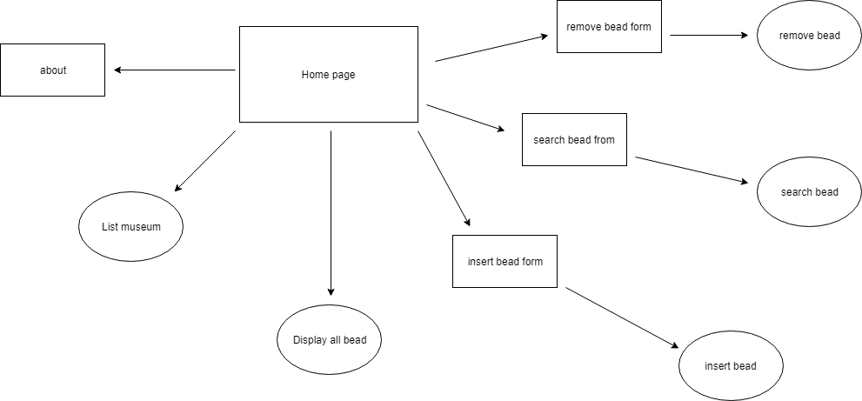

1. Home page
   1. Links to other bead pages, and features a broad open search for users
2. Museum page
   1. Page that lists museums that currently house beads related to viking mythology
3. Bead Listing Page
   1. A complete list of beads in the database
4. Submit bead pages
   1. Page that allows a user to upload a new bead
5. Search bead pages
   1. Users can search for particular bead
6. Bead Removal Pages
   1. Removes inauthentic or inaccurate beads from database
7. about  page
   1. Listing of group members involved

# Website Demo – offline mode

## Display [Backup]

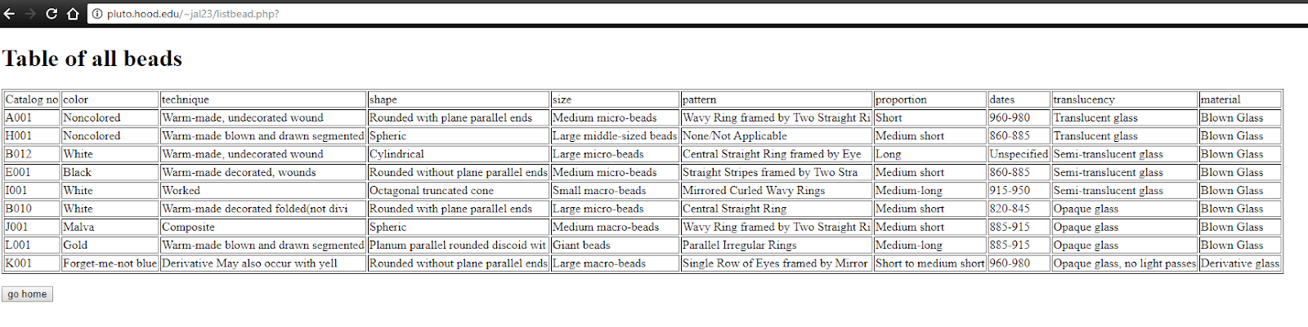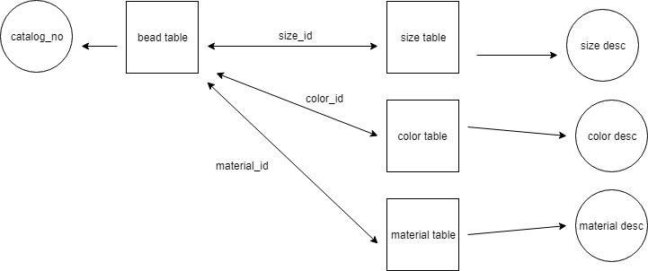

## Insert [Backup]

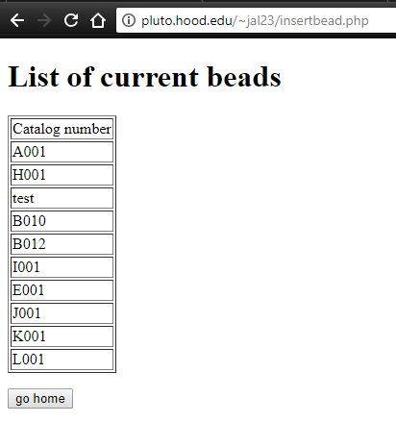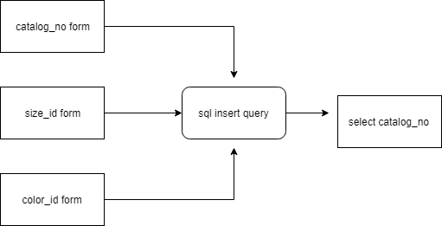

## Remove[Backup]

